**Introduction**

6

02

**Background**

**System Implementation**

**Rate Accuracy Experiments**

**Traffic Monitoring Application**

**Conclusion, Limitations and Future Work**

**Models Evaluation**

04

07

06

05

01

03

slide in Word

Fsdfsdddddddddddddddddd

Gfssssssssssssssssss

Ghhhhhhhhhhhhhhhhhhhhhhhhhhhhhhhhh

Fggggggggggggggggggggggggggggggggggggg

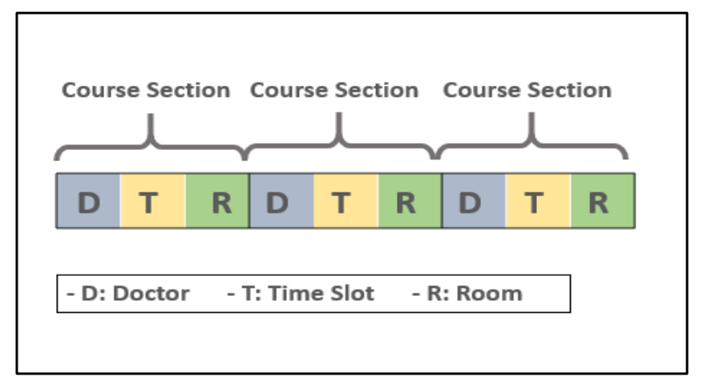

fdsfsdf